Carboxylic acids
- Draw the structures of the following compounds:
  - ethanoic acid

  - 3-chloropropanoic acid

  - 4-amino-2,3-dimethylbutanoic acid

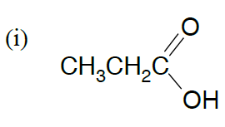
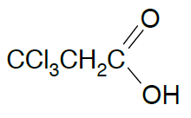
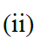
- Name these compounds:

